Internet of Things

**1. Introduction:**

**Definition of IoT**

Internet of Things (IoT) is the networking of physical objects that contain electronics embedded within their architecture in order to communicate and sense interactions amongst each other or with respect to the external environment. In the upcoming years, IoT-based technology will offer advanced levels of services and practically change the way people lead their daily lives. Advancements in medicine, power, gene therapies, agriculture, smart cities, and smart homes are just a very few of the categorical examples where IoT is strongly established. Over 9 billion ‘Things’ (physical objects) are currently connected to the Internet, as of now. In the near future, this number is expected to rise to a whopping 20 billion.

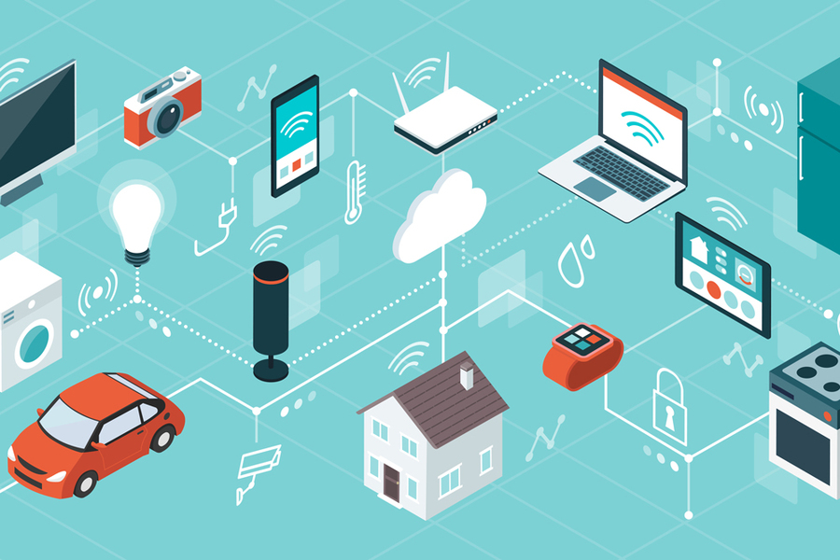

Fig.1 – IoT overview

There are four main components used in IoT:

* Low-power embedded systems: Less battery consumption, high performance are the inverse factors that play a significant role during the design of electronic systems.
* Cloud computing: Data collected through IoT devices is massive and this data has to be stored on a reliable storage server. This is where cloud computing comes into play. The data is processed and learned, giving more room for us to discover where things like electrical faults/errors are within the system.
* Availability of big data: We know that IoT relies heavily on sensors, especially in real-time. As these electronic devices spread throughout every field, their usage is going to trigger a massive flux of big data.
* Networking connection: In order to communicate, internet connectivity is a must where each physical object is represented by an IP address. However, there are only a limited number of addresses available according to the IP naming. Due to the growing number of devices, this naming system will not be feasible anymore. Therefore, researchers are looking for another alternative naming system to represent each physical object.

There are two ways of building IoT:

* Form a separate internetwork including only physical objects.
* Make the Internet ever more expansive, but this requires hard-core technologies such as rigorous cloud computing and rapid big data storage (expensive).

In the near future, IoT will become broader and more complex in terms of scope. It will change the world in terms of

“anytime, anyplace, anything in connectivity.”

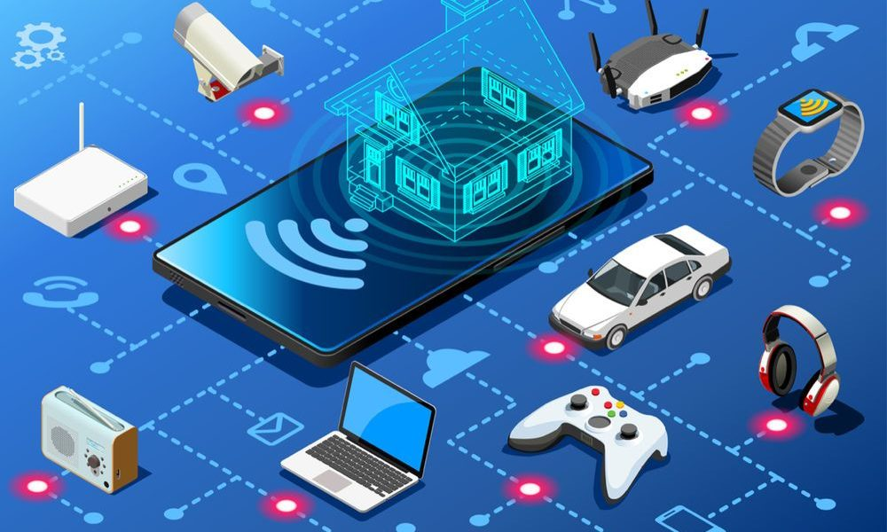

Fig.2 – IoT working

The Internet of Things is the latest big buzz around the globe. It is in demand technology which is closest to a human being, closest to his or her lifestyle. It is based on machine-to-machine communication, cloud computing and network of data gathering sensors. The basic motto behind IoT is that it assures that it will make everything from a light bulb to railway stations “smart”.

When we talk about IoT, we usually talk about M2M (machine-to-machine) relationships but M2M is not everything. The most important aspect is cloud. Via cloud only the machines can access data anytime anywhere and work without any glitches and give smooth outputs. The data transfers are conducted through sensors.

Let us understand through an example. Suppose the electric cables used on metro train bridges are made up of copper from inside and that copper is replaced by smart copper. Smart copper is nothing but copper having sensors which are wirelessly connected to cloud which is later connected to machines wirelessly. So, in future if there will be any breakage or any other kind of physical or functional damage to the wire, the sensors will record and transfer relevant report to the respective authority wirelessly via cloud.

This whole process will help the system in three ways:

• Physical labor and time can be saved in finding the problem in the wire

• Instead of changing the whole wire, only parts effected can be monitored and changed

• Daily report of wires which may include its temperature, tension and even amount of current transferred can be received.

Even in future if the wire is covered with snow, this can also be monitored and dotted down wirelessly.

So overall IoT is the BIG CHANGE for the orb.

Now what is Internet of Everything (IoE)?

This is no different but is a further intelligent connection between things and devices, people, processes and data. It makes sensor’s information more meaningful, secure and more stable. It helps the business ecosystem to groom.

**2. Characteristics of IoT:**

* Massively scalable and efficient
* IP-based addressing will no longer be suitable in the upcoming future.
* An abundance of physical objects is present that do not use IP, so IoT is made possible.
* Devices typically consume less power. When not in use, they should be automatically programmed to sleep.
* A device that is connected to another device right now may not be connected in another instant of time.
* Intermittent connectivity – IoT devices aren’t always connected. In order to save bandwidth and battery consumption, devices will be powered off periodically when not in use. Otherwise, connections might turn unreliable and thus prove to be inefficient.
* As a quick note, IoT incorporates trillions of sensors, billions of smart systems, and millions of applications.

**Application Domains:**

IoT is currently found in four different popular domains:

1) Manufacturing/Industrial business - 40.2%

2) Healthcare - 30.3%

3) Security - 7.7%

4) Retail - 8.3%

**Modern Applications:**

* Smart Grids and energy saving
* Smart cities
* Smart homes
* Healthcare
* Earthquake detection
* Radiation detection/hazardous gas detection
* Smartphone detection
* Water flow monitoring
* Traffic monitoring
* Wearables

**3. Design Considerations for IoT Applications:**

Connecting products to the Internet of Things (IoT) is essential to manufacturers looking to stay competitive within their industry. Adding IoT capabilities gives consumers more features. It also allows the manufacturer to stay connected with their customer while discovering new product use cases and applications that open them up to new revenue streams. When designing your first IoT device, there are 10 things to keep in mind:

1. Cost

“Smart” or IoT products help consumers and manufacturers alike, but they cost more. Both Ethernet and wireless technologies have come down below $10, so consider networking in your next product.

2. Network

The network technology you chose for your IoT product has distance and gateway/router issues. If you need to get to the Internet then you need Ethernet/Wi-Fi; if you are self-contained in a room or building then ZigBee, Z-Wave, and Bluetooth are available. Remember all wireless technologies need FCC certification.

3. Features

With an IoT connected product, companies can now add features to their products that were not possible or imagined. These features can get you direct access to the customer for updates, maintenance, and new revenue opportunities.

4. User interface

How the user interfaces with a product are important. Are you going to use buttons, LEDs, or a display on the product? Also, what web and app interfaces are you going to provide?

5. Power

One of the first decisions should be the power source. If the device will be powered by batteries, then all design decisions must consider how to preserve power. Many networking technologies will not be a good fit with battery power. Frequency of communication does have an influence on power selection, too.

6. Size

Size matters. Consider how the network will impact the size of the device. Connectors and antennas required by some networks will add to the size.

7. Antenna

All wireless networks use an antenna, internal or external to the product. The trend is to move the antenna inside the enclosure if it is plastic. All metal enclosures would require external antennas.

8. Cloud

Cloud applications provide products a user interface to the product and the data. There are private and public clouds. Most clouds have a standard API for developing your application.

9. Interoperability

Does your product need to communicate with other vendors’ products? If so, then you need to adopt a standard set of protocols, such as Apple’s HomeKit, to communicate with other products.

10. Security

Security is becoming a major issue, so you need to design in as many layers of security as feasible. SSL and password are the minimum.